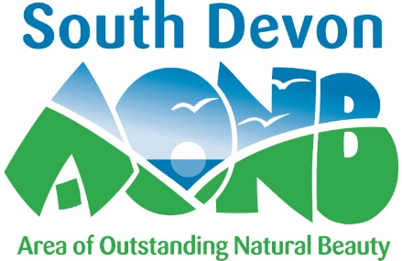

Partnership Committee: Election of Community Representatives 2021 Nomination Form

Category of nomination (tick the box or boxes which apply):
- Representing amenity groups of the AONB
- Representing the landowning or farming community of the AONB

Representing the business community of the AONB
- Representing the non-governmental professional organisations active in the environmental management of the AONB
- Representing community or voluntary groups active in the AONB
- Representing parish/town councils in the AONB.
- Representing the tourism sector in the AONB
- Representing the coast and marine sector of the AONB

Name of nominee

Address of nominee

Telephone

E-mail

Nominated by: organisation/ local group /self

Statement by the nominee (maximum 200 words)
What relevant experience would you bring to the work of the AONB Partnership?

What are your particular fields of interest?

What relevant organisations are you involved with?

Please complete this form electronically and email enquiries@southdevonaonb.org.uk or print and post the completed form by 9am Tuesday 26th October to the South Devon AONB Unit, Follaton House, Totnes, TQ9 5NE.

